**CMPE-272 SERVERLESS FRAMEWORK**

Here we actually tried to play with different features of lambda functions to make 2 tasks.

**Task-1:** Starting serverless framework with hands on using S3 bucket list. We have tried to retrieve S3 bucket list using lambda application.

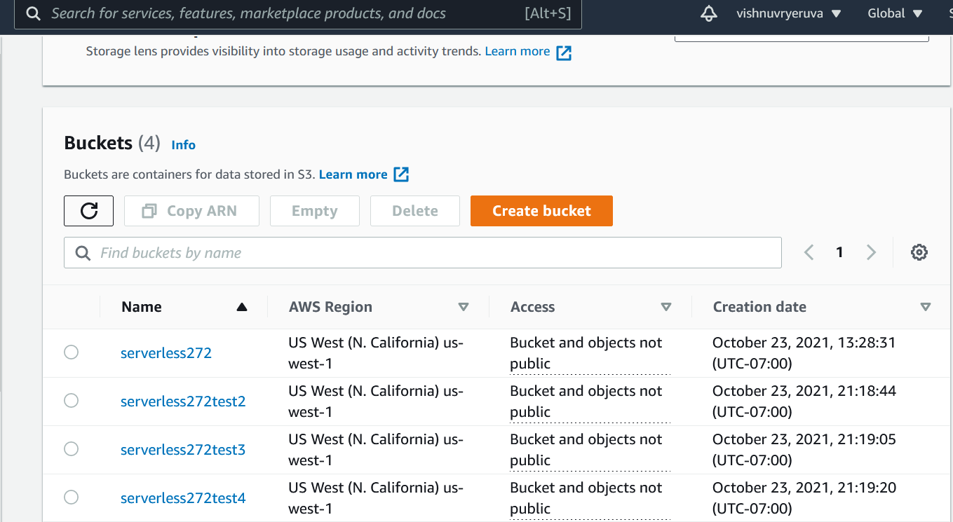

**FIG S3 BUCKET LIST**

After Execution: Able to retrieve them

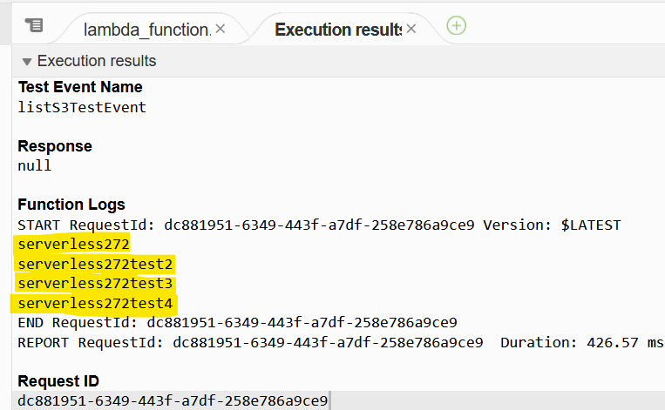

**Task-2:** Here we actually tried to create items in a table by taking advantage of lambda function.

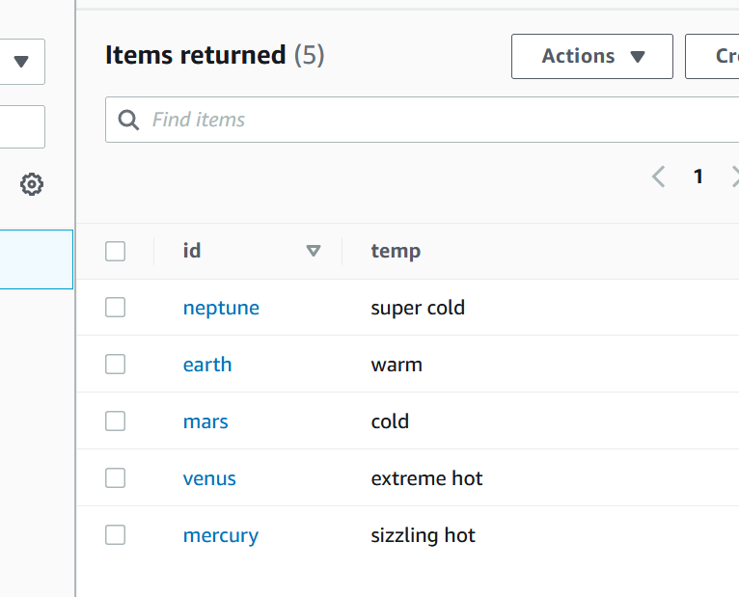

**FIG DYNAMO DB Table**

Here we already made a table with few fields in it using Dynamo DB in order to make the table not null.

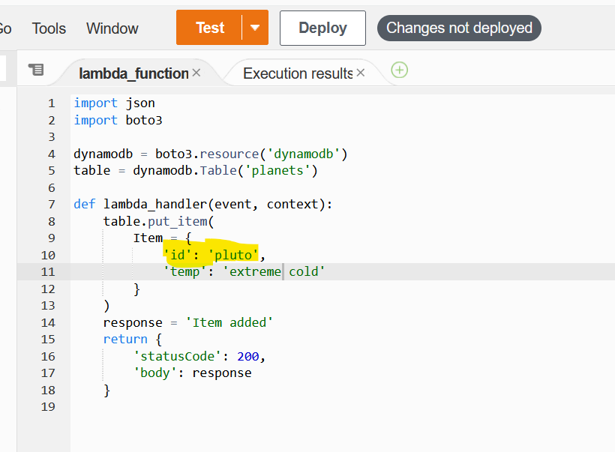

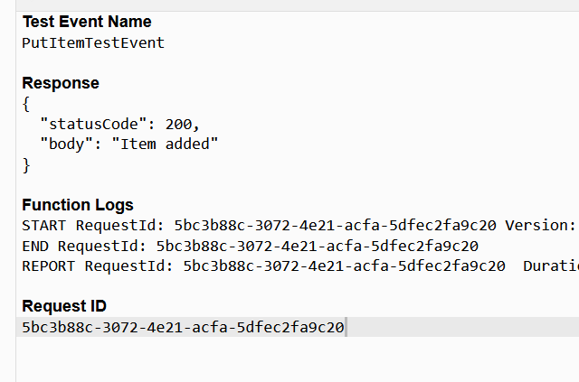

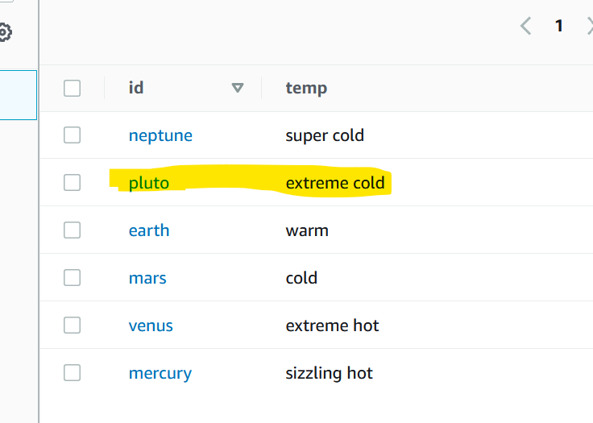

Pluto got added.

Note: Please refer to [Git_link](https://github.com/vishnuvryeruva/Serverless-Framework) for further information on code.